**Experiment – 5**

# Bootstrap

## What is Bootstrap?

Bootstrap is a powerful front-end framework for faster and easier web development. It includes HTML and CSS based design templates for creating common user interface components like forms, buttons, navigations, dropdowns, alerts, modals, tabs, accordions, carousels, tooltips, and so on.

## What You Can Do with Bootstrap

There are lot more things you can do with Bootstrap.

* You can easily create responsive websites.
* You can quickly create multi-column layout with pre-defined classes.
* You can quickly create different types of form layouts.
* You can quickly create different variation of navigation bar.
* You can easily create components like accordions, modals, etc. without writing any JS code.
* You can easily create dynamic tabs to manage large amount of content.
* You can easily create tooltips and popovers to show hint text.
* You can easily create carousel or image slider to showcase your content.
* You can quickly create different types of alert boxes.

## Advantages of Using Bootstrap

If you have had some experience with any front-end framework, you might be wondering what makes Bootstrap so special. Here are some advantages why one should opt for Bootstrap framework:

* Save lots of time— You can save lots of time and efforts using the Bootstrap predefined design templates and classes and concentrate on other development work.
* Responsive features— Using Bootstrap you can easily create responsive websites that appear more appropriately on different devices and screen resolutions without any change in markup.
* Consistent design— All Bootstrap components share the same design templates and styles through a central library, so the design and layout of your web pages will be consistent.
* Easy to use— Bootstrap is very easy to use. Anybody with the basic working knowledge of HTML, CSS and JavaScript can start development with Bootstrap.
* Compatible with browsers— Bootstrap is created with modern web browsers in mind and it is compatible with all modern browsers such as Chrome, Firefox, Safari, Internet Explorer, etc.
* Open Source— And the best part is, it is completely free to download and use.

**Assignment 1**

1. Create ecommerce website with products in category Electronics, Clothing, Furniture
2. Apply following
3. Bootstrap Grid system to create column layouts
4. Bootstrap tables (table with alternate background)
5. Bootstrap buttons
6. Bootstrap Navbar, breadcrumps, pagination
7. Bootstrap badges // Notification box
8. Bootstrap Progress Bar
9. Modals, Tabs, Tooltips, Carousal

**HTML:**

**HOME PAGE**

<!doctype html>

<html lang="en">

<head>

  <!-- Required meta tags -->

  <meta charset="utf-8">

  <meta name="viewport" content="width=device-width, initial-scale=1, shrink-to-fit=no">

  <!-- Bootstrap CSS -->

  <link rel="stylesheet" href="https://stackpath.bootstrapcdn.com/bootstrap/4.4.1/css/bootstrap.min.css" integrity="sha384-Vkoo8x4CGsO3+Hhxv8T/Q5PaXtkKtu6ug5TOeNV6gBiFeWPGFN9MuhOf23Q9Ifjh" crossorigin="anonymous">

  <title id="logo">ChiragSales</title>

</head>

<body>

  <div class="modal fade" id="exampleModal" tabindex="-1" role="dialog" aria-labelledby="exampleModalLabel" aria-hidden="true">

    <div class="modal-dialog" role="document">

      <div class="modal-content">

        <div class="modal-header">

          <h5 class="modal-title" id="exampleModalLabel">Notifications</h5>

          <button type="button" class="close" data-dismiss="modal" aria-label="Close">

            <span aria-hidden="true">&times;</span>

          </button>

        </div>

        <div class="modal-body">

          <!-- Bootstrap tables -->

<table class="table table-striped text-center">

<thead>

  <tr>

    <th scope="col">#</th>

    <th scope="col">Available Sizes</th>

    <th scope="col">Available Colours</th>

    <th scope="col">Available Brands</th>

  </tr>

</thead>

<tbody>

  <tr>

    <th scope="row">1</th>

    <td><button type="button" class="btn  btn-dark">25</button></td>

    <td><button type="button" class="btn  btn-warning">Yellow</button></td>

    <td><button type="button" class="btn  btn-outline-warning"><strong>Champion</strong></button></td>

  </tr>

  <tr>

    <th scope="row">2</th>

    <td><button type="button" class="btn btn-centre btn-dark">27</button></td>

    <td><button type="button" class="btn btn-centre btn-danger">Red</button></td>

    <td><button type="button" class="btn  btn-outline-danger"><strong>Calvin Klein</strong></button></td>

  </tr>

  <tr>

    <th scope="row">3</th>

    <td><button type="button" class="btn btn-dark">32</button></td>

    <td><button type="button" class="btn btn-success">Green</button></td>

    <td><button type="button" class="btn  btn-outline-success"><strong>BIBA</strong></button></td>

  </tr>

</tbody>

</table>

        </div>

        <div class="modal-footer">

          <button type="button" class="btn btn-secondary" data-dismiss="modal">Close</button>

          <button type="button" class="btn btn-primary">Clear All</button>

        </div>

      </div>

    </div>

  </div>

  <!--Navigation Bar-->

  <nav class="navbar navbar-expand-lg navbar-dark bg-dark sticky-top">

    <a class="navbar-brand text-danger font-weight-bold" data-toggle="tooltip" data-placement="bottom" title="About The Company" id="logo" href="#">ChiragSales</a>

    <button class="navbar-toggler" type="button" data-toggle="collapse" data-target="#navbarSupportedContent" aria-controls="navbarSupportedContent" aria-expanded="false" aria-label="Toggle navigation">

      <span class="navbar-toggler-icon"></span>

    </button>

    <div class="collapse navbar-collapse" id="navbarSupportedContent">

      <ul class="navbar-nav ml-auto">

        <li class="nav-item active">

          <a class="nav-link" href="index.html">Home <span class="sr-only">(current)</span></a>

        </li>

        <li class="nav-item">

          <a class="nav-link" href="#">Login</a>

        </li>

        <li class="nav-item dropdown">

          <a class="nav-link dropdown-toggle" href="#" id="navbarDropdown" role="button" data-toggle="dropdown" aria-haspopup="true" aria-expanded="false">

            Dropdown

          </a>

          <div class="dropdown-menu " aria-labelledby="navbarDropdown">

            <a class="dropdown-item" href="electronics.html">Electronics</a>

            <div class="dropdown-divider"></div>

            <a class="dropdown-item" href="clothing.html">Clothes</a>

            <div class="dropdown-divider"></div>

            <a class="dropdown-item" href="clothing.html">Furniture</a>

          </div>

        </li>

        <li class="nav-item ">

          <a class="nav-link" href="#" tabindex="-1" aria-disabled="true">

            <button type="button" class="btn btn-danger">

              Notification <span class="badge badge-light">4</span>

              <span class="sr-only">unread messages</span>

            </button>

          </a>

        </li>

      </ul>

      <form class="form-inline my-2 my-lg-0">

        <input class="form-control mr-sm-2" type="search" placeholder="Search" aria-label="Search">

        <button class="btn btn-outline-success my-2 my-sm-0" type="submit">Search</button>

      </form>

    </div>

  </nav>

  <!-- BreadCrumb -->

  <nav aria-label="breadcrumb">

    <ol class="breadcrumb">

      <li class="breadcrumb-item active" aria-current="page">Home</li>

    </ol>

  </nav>

  <!-- Carouse -->

  <div id="carouselExampleIndicators" height="" class="carousel slide" data-ride="carousel">

    <ol class="carousel-indicators">

      <li data-target="#carouselExampleIndicators" data-slide-to="0" class="active"></li>

      <li data-target="#carouselExampleIndicators" data-slide-to="1"></li>

      <li data-target="#carouselExampleIndicators" data-slide-to="2"></li>

    </ol>

    <div class="carousel-inner">

      <div class="carousel-item active">

        <img src="img/headphone.jpg" class="d-block w-100" alt="electronics">

        <div class="carousel-caption text-dark text-left">

          <h1>HeadPhones</h1>

          <h3> Best in the market</h3>

          <button type="button" class="btn btn-outline-large btn-lg">View Details</button>

          <button type="button"class="btn btn-primary">Claim Offer</button>

        </div>

      </div>

      <div class="carousel-item">

        <img src="img/clothes.jpg" class="d-block w-100" alt="Clothes">

        <div class="carousel-caption">

          <h1>Formals</h1>

          <h3>Dress like a Charm</h3>

          <button type="button" class="btn btn-outline-large btn-lg">View Details</button>

          <button type="button"class="btn btn-primary">Try Now</button>

        </div>

      </div>

      <div class="carousel-item">

        <img src="img/furniture.jpg" class="d-block w-100" alt="fURNITURE">

        <div class="carousel-caption">

          <h1>Comfort King</h1>

          <h3>Let your guest have a reason to stay  </h3>

          <button type="button" class="btn btn-outline-large btn-lg">View Details</button>

          <button type="button"class="btn btn-primary">AR NOW</button>

        </div>

      </div>

    </div>

    <a class="carousel-control-prev" href="#carouselExampleIndicators" role="button" data-slide="prev">

      <span class="carousel-control-prev-icon" aria-hidden="true"></span>

      <span class="sr-only">Previous</span>

    </a>

    <a class="carousel-control-next" href="#carouselExampleIndicators" role="button" data-slide="next">

      <span class="carousel-control-next-icon" aria-hidden="true"></span>

      <span class="sr-only">Next</span>

    </a>

  </div>

  <!-- END OF Carousel -->

 <!-- USing a Grid System of Bootstrap -->

  <div class="container">

    <div class="row">

      <div class="col-md-4">

        <div class="card mb-4 shadow-sm">

          <img class="card-img-top" src="img/supermancloth.jpg" alt="Card image" style="width:100%">

          <div class="card-body">

            <h4 class="card-title">Super Man Suit</h4>

            <p class="card-text">This suit is made specially for kids</p>

            <a href="img/supermancloth.jpg" data-target="#exampleModal" data-toggle="modal"class="btn btn-primary">View Details</a>

          </div>

        </div>

      </div>

      <div class="col-md-4">

        <div class="card mb-4 shadow-sm">

          <img class="card-img-top" src="img/supermancloth.jpg" alt="Card image" style="width:100%">

          <div class="card-body">

            <h4 class="card-title">Super Man Suit</h4>

            <p class="card-text">This suit is made specially for kids</p>

            <a href="img/supermancloth.jpg" data-target="#exampleModal" data-toggle="modal"class="btn btn-primary">View Details</a>

          </div>

        </div>

      </div>

      <div class="col-md-4">

        <div class="card mb-4 shadow-sm">

          <img class="card-img-top" src="img/supermancloth.jpg" alt="Card image" style="width:100%">

          <div class="card-body">

            <h4 class="card-title">Super Man Suit</h4>

            <p class="card-text">This suit is made specially for kids</p>

            <a href="img/supermancloth.jpg" data-target="#exampleModal" data-toggle="modal"class="btn btn-primary">View Details</a>

          </div>

        </div>

      </div>

      <div class="col-md-4">

        <div class="card mb-4 shadow-sm">

          <img class="card-img-top" src="img/onplus6t.jpg" alt="Card image" style="width:100%">

          <div class="card-body">

            <h4 class="card-title">One PLus 6t</h4>

            <p class="card-text">The Biggest Scam of my life, they dropped 10k on it.</p>

            <a href="img/onplus6t.jpg" class="btn btn-primary">View Details</a>

          </div>

        </div>

      </div>

      <div class="col-md-4">

        <div class="card mb-4 shadow-sm">

          <img class="card-img-top" src="img/onplus6t.jpg" alt="Card image" style="width:100%">

          <div class="card-body">

            <h4 class="card-title">One PLus 6t</h4>

            <p class="card-text">The Biggest Scam of my life, they dropped 10k on it.</p>

            <a href="img/onplus6t.jpg" class="btn btn-primary">View Details</a>

          </div>

        </div>

      </div>

      <div class="col-md-4">

        <div class="card mb-4 shadow-sm">

          <img class="card-img-top" src="img/onplus6t.jpg" alt="Card image" style="width:100%">

          <div class="card-body">

            <h4 class="card-title">One PLus 6t</h4>

            <p class="card-text">The Biggest Scam of my life, they dropped 10k on it.</p>

            <a href="img/onplus6t.jpg" class="btn btn-primary">View Details</a>

          </div>

        </div>

      </div>

      <div class="col-md-4">

        <div class="card mb-4 shadow-sm">

          <img class="card-img-top" src="img/sofachair.jpg" alt="Card image" style="width:100%">

          <div class="card-body">

            <h4 class="card-title">The Comfort Chair</h4>

            <p class="card-text">Best Place to rest and a neighbour/relative attraction.</p>

            <a href="img/sofachair.jpg" class="btn btn-primary">View Details</a>

          </div>

        </div>

      </div>

      <div class="col-md-4">

        <div class="card mb-4 shadow-sm">

          <img class="card-img-top" src="img/sofachair.jpg" alt="Card image" style="width:100%">

          <div class="card-body">

            <h4 class="card-title">The Comfort Chair</h4>

            <p class="card-text">Best Place to rest and a neighbour/relative attraction.</p>

            <a href="img/sofachair.jpg" class="btn btn-primary">View Details</a>

          </div>

        </div>

      </div>

      <div class="col-md-4">

        <div class="card mb-4 shadow-sm">

          <img class="card-img-top" src="img/sofachair.jpg" alt="Card image" style="width:100%">

          <div class="card-body">

            <h4 class="card-title">The Comfort Chair</h4>

            <p class="card-text">Best Place to rest and a neighbour/relative attraction.</p>

            <a href="img/sofachair.jpg" class="btn btn-primary">View Details</a>

          </div>

        </div>

      </div>

  </div>

</div>

<!-- Optional JavaScript -->

<!-- jQuery first, then Popper.js, then Bootstrap JS -->

<script src="https://code.jquery.com/jquery-3.4.1.slim.min.js" integrity="sha384-J6qa4849blE2+poT4WnyKhv5vZF5SrPo0iEjwBvKU7imGFAV0wwj1yYfoRSJoZ+n" crossorigin="anonymous"></script>

<script src="https://cdn.jsdelivr.net/npm/popper.js@1.16.0/dist/umd/popper.min.js" integrity="sha384-Q6E9RHvbIyZFJoft+2mJbHaEWldlvI9IOYy5n3zV9zzTtmI3UksdQRVvoxMfooAo" crossorigin="anonymous"></script>

<script src="https://stackpath.bootstrapcdn.com/bootstrap/4.4.1/js/bootstrap.min.js" integrity="sha384-wfSDF2E50Y2D1uUdj0O3uMBJnjuUD4Ih7YwaYd1iqfktj0Uod8GCExl3Og8ifwB6" crossorigin="anonymous"></script>

</body>

</html>

**Output:**

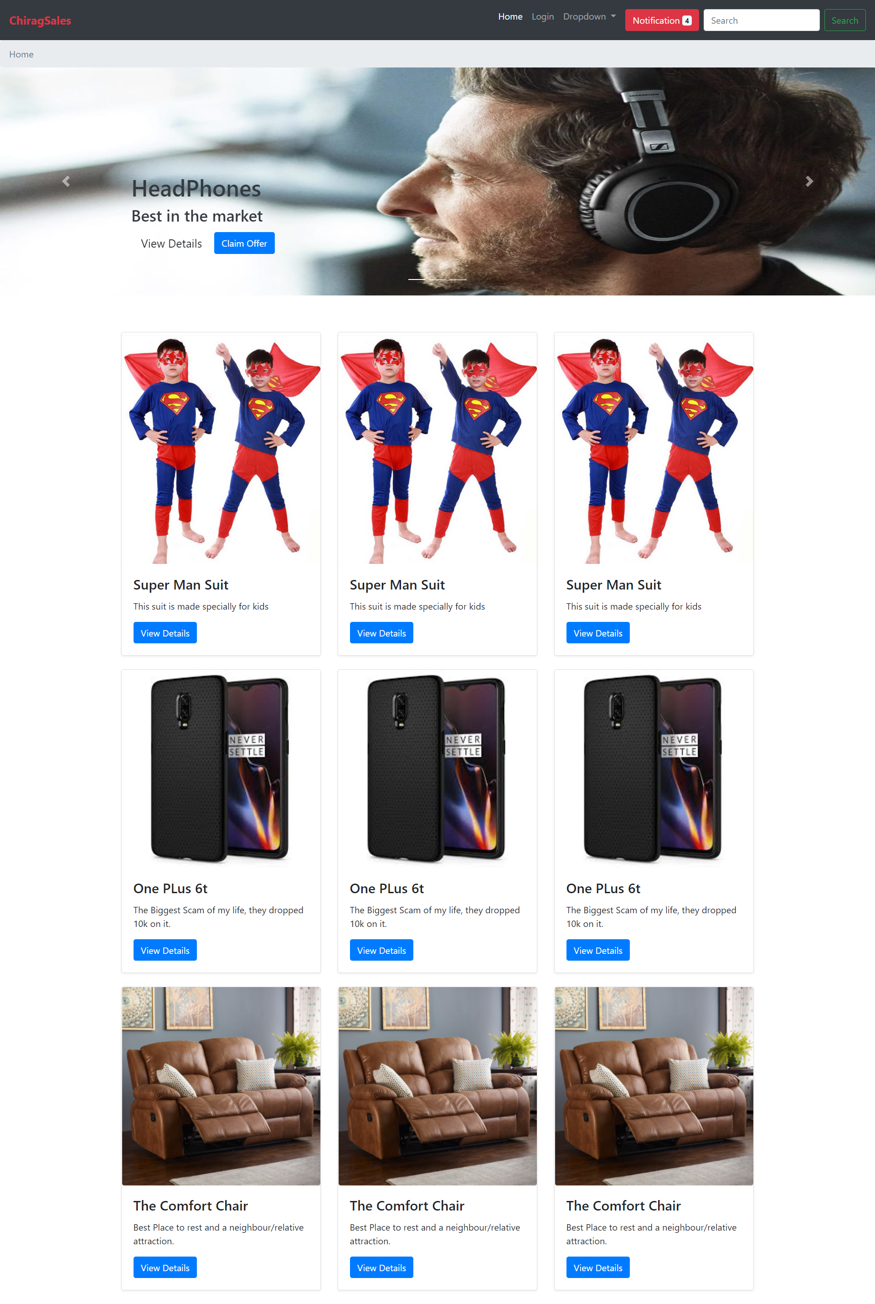

**HTML CODE for Clothes.html**

<!doctype html>

<html lang="en">

  <head>

    <!-- Required meta tags -->

    <meta charset="utf-8">

    <meta name="viewport" content="width=device-width, initial-scale=1, shrink-to-fit=no">

    <!-- Bootstrap CSS -->

    <link rel="stylesheet" href="https://stackpath.bootstrapcdn.com/bootstrap/4.4.1/css/bootstrap.min.css" integrity="sha384-Vkoo8x4CGsO3+Hhxv8T/Q5PaXtkKtu6ug5TOeNV6gBiFeWPGFN9MuhOf23Q9Ifjh" crossorigin="anonymous">

    <link rel="stylesheet" href="style.css">

    <title id="logo">ChiragSales</title>

  </head>

  <body>

    <div class="modal fade" id="exampleModal" tabindex="-1" role="dialog" aria-labelledby="exampleModalLabel" aria-hidden="true">

      <div class="modal-dialog" role="document">

        <div class="modal-content">

          <div class="modal-header">

            <h5 class="modal-title" id="exampleModalLabel">Notifications</h5>

            <button type="button" class="close" data-dismiss="modal" aria-label="Close">

              <span aria-hidden="true">&times;</span>

            </button>

          </div>

          <div class="modal-body">

            <!-- Bootstrap tables -->

 <table class="table table-striped text-center">

  <thead>

    <tr>

      <th scope="col">#</th>

      <th scope="col">Available Sizes</th>

      <th scope="col">Available Colours</th>

      <th scope="col">Available Brands</th>

    </tr>

  </thead>

  <tbody>

    <tr>

      <th scope="row">1</th>

      <td><button type="button" class="btn  btn-dark">25</button></td>

      <td><button type="button" class="btn  btn-warning">Yellow</button></td>

      <td><button type="button" class="btn  btn-outline-warning"><img src="img/clothbrand1.jpg" alt="" class="img-fluid"></button></td>

    </tr>

    <tr>

      <th scope="row">2</th>

      <td><button type="button" class="btn btn-centre btn-dark">27</button></td>

      <td><button type="button" class="btn btn-centre btn-danger">Red</button></td>

      <td><button type="button" class="btn  btn-outline-danger"><img src="img/clothbrand2.png" alt="" class="img-fluid"></button></td>

    </tr>

    <tr>

      <th scope="row">3</th>

      <td><button type="button" class="btn btn-dark">32</button></td>

      <td><button type="button" class="btn btn-success">Green</button></td>

      <td><button type="button" class="btn  btn-outline-success"><img src="img/clothbrand3.png" alt="" class="img-fluid"></button></td>

    </tr>

  </tbody>

</table>

          </div>

          <div class="modal-footer">

            <button type="button" class="btn btn-secondary" data-dismiss="modal">Close</button>

            <button type="button" class="btn btn-primary">Clear All</button>

          </div>

        </div>

      </div>

    </div>

    <!--Navigation Bar-->

<!-- New nav -->

<nav class="navbar navbar-expand-lg navbar-dark bg-dark sticky-top">

  <a class="navbar-brand text-danger font-weight-bold" id="logo" href="#">ChiragSales</a>

  <button class="navbar-toggler" type="button" data-toggle="collapse" data-target="#navbarSupportedContent" aria-controls="navbarSupportedContent" aria-expanded="false" aria-label="Toggle navigation">

    <span class="navbar-toggler-icon"></span>

  </button>

<div class="collapse navbar-collapse" id="navbarSupportedContent">

  <ul class="navbar-nav ml-auto">

    <li class="nav-item active">

      <a class="nav-link" href="index.html">Home <span class="sr-only">(current)</span></a>

    </li>

    <li class="nav-item">

      <a class="nav-link" href="#">Login</a>

    </li>

    <li class="nav-item dropdown">

      <a class="nav-link dropdown-toggle" href="#" id="navbarDropdown" role="button" data-toggle="dropdown" aria-haspopup="true" aria-expanded="false">

        Clothes

      </a>

       <div class="dropdown-menu " aria-labelledby="navbarDropdown">

        <a class="dropdown-item " href="electronics.html">Electronics</a>

         <div class="dropdown-divider"></div>

         <a class="dropdown-item active" href="clothing.html">Clothes</a>

        <div class="dropdown-divider"></div>

        <a class="dropdown-item" href="furniture.html">Furniture</a>

      </div>

    </li>

    <li class="nav-item ">

      <a class="nav-link" href="#" tabindex="-1" aria-disabled="true">

        <button type="button" class="btn btn-danger">

          Notification <span class="badge badge-light">4</span>

          <span class="sr-only">unread messages</span>

        </button>

      </a>

    </li>

  </ul>

  <form class="form-inline my-2 my-lg-0">

    <input class="form-control mr-sm-2" type="search" placeholder="Search" aria-label="Search">

    <button class="btn btn-outline-success my-2 my-sm-0" type="submit">Search</button>

  </form>

</div>

</nav>

<!-- BreadCrumb -->

<nav aria-label="breadcrumb">

  <ol class="breadcrumb">

    <li class="breadcrumb-item" ><a href="index.html">Home</a></li>

    <li class="breadcrumb-item" aria-current="page">Clothing</li>

  </ol>

</nav>

<!-- Carouse -->

<div id="carouselExampleIndicators" height="" class="carousel slide" data-ride="carousel">

  <ol class="carousel-indicators">

    <li data-target="#carouselExampleIndicators" data-slide-to="0" class="active"></li>

    <li data-target="#carouselExampleIndicators" data-slide-to="1"></li>

    <li data-target="#carouselExampleIndicators" data-slide-to="2"></li>

  </ol>

  <div class="carousel-inner">

    <div class="carousel-item active">

      <img src="img/headphone.jpg" class="d-block w-100" alt="...">

    </div>

    <div class="carousel-item">

      <img src="img/clothes.jpg" class="d-block w-100" alt="...">

    </div>

    <div class="carousel-item">

      <img src="img/furniture.jpg" class="d-block w-100" alt="...">

    </div>

  </div>

  <a class="carousel-control-prev" href="#carouselExampleIndicators" role="button" data-slide="prev">

    <span class="carousel-control-prev-icon" aria-hidden="true"></span>

    <span class="sr-only">Previous</span>

  </a>

  <a class="carousel-control-next" href="#carouselExampleIndicators" role="button" data-slide="next">

    <span class="carousel-control-next-icon" aria-hidden="true"></span>

    <span class="sr-only">Next</span>

  </a>

</div>

 <div class="container marketing">

  <!-- Three columns of text below the carousel -->

  <!-- START THE FEATURETTES -->

  <hr class="featurette-divider">

  <div class="row featurette">

    <div class="col-md-7">

      <h2 class="featurette-heading">First featurette heading. <span class="text-muted">It’ll blow your mind.</span></h2>

      <p class="lead">Donec ullamcorper nulla non metus auctor fringilla. Vestibulum id ligula porta felis euismod semper. Praesent commodo cursus magna, vel scelerisque nisl consectetur. Fusce dapibus, tellus ac cursus commodo.</p>

      <button class="btn btn-primary" data-target="#exampleModal" data-toggle="modal">See all buying Option</button>

      <div class="progress mt-2">

        <div class="progress-bar progress-bar-striped progress-bar-animated" role="progressbar" aria-valuenow="75" aria-valuemin="0" aria-valuemax="100" style="width: 100%"></div>

      </div>

  </div>

    <div class="col-md-5">

      <img src="img/gingham.jpg" alt="">

    </div>

  </div>

  <hr class="featurette-divider">

  <div class="row featurette">

    <div class="col-md-7 order-md-2">

      <h2 class="featurette-heading">Oh yeah, it’s that good. <span class="text-muted">See for yourself.</span></h2>

      <p class="lead">Donec ullamcorper nulla non metus auctor fringilla. Vestibulum id ligula porta felis euismod semper. Praesent commodo cursus magna, vel scelerisque nisl consectetur. Fusce dapibus, tellus ac cursus commodo.</p>

      <button class="btn btn-primary" data-target="#exampleModal" data-toggle="modal">See all buying Option</button>

      <div class="progress mt-2">

        <div class="progress-bar progress-bar-striped progress-bar-animated" role="progressbar" aria-valuenow="75" aria-valuemin="0" aria-valuemax="100" style="width: 100%"></div>

      </div>

    </div>

    <div class="col-md-5 order-md-1">

      <img src="img/baytsuit.jpg" alt="">

    </div>

  </div>

  <hr class="featurette-divider">

  <div class="row featurette">

    <div class="col-md-7">

      <h2 class="featurette-heading">And lastly, this one. <span class="text-muted">Checkmate.</span></h2>

      <p class="lead">Donec ullamcorper nulla non metus auctor fringilla. Vestibulum id ligula porta felis euismod semper. Praesent commodo cursus magna, vel scelerisque nisl consectetur. Fusce dapibus, tellus ac cursus commodo.</p>

      <button class="btn btn-primary" data-target="#exampleModal" data-toggle="modal">See all buying Option</button>

      <div class="progress">

        <div class="progress-bar progress-bar-striped progress-bar-animated" role="progressbar" aria-valuenow="75" aria-valuemin="0" aria-valuemax="100" style="width: 100%"></div>

      </div>

    </div>

    <div class="col-md-5">

      <img src="img/babasuit.jpg" alt="">

    </div>

  </div>

  <hr class="featurette-divider">

  <!-- /END THE FEATURETTES -->

  <nav aria-label="Page navigation example">

    <ul class="pagination justify-content-center">

      <li class="page-item"><a class="page-link" href="#">Previous</a></li>

      <li class="page-item"><a class="page-link" href="#">1</a></li>

      <li class="page-item"><a class="page-link" href="#">2</a></li>

      <li class="page-item"><a class="page-link" href="#">3</a></li>

      <li class="page-item"><a class="page-link" href="#">Next</a></li>

    </ul>

  </nav>

</div><!-- /.container -->

</div>

    <!-- Optional JavaScript -->

    <!-- jQuery first, then Popper.js, then Bootstrap JS -->

    <script src="https://code.jquery.com/jquery-3.4.1.slim.min.js" integrity="sha384-J6qa4849blE2+poT4WnyKhv5vZF5SrPo0iEjwBvKU7imGFAV0wwj1yYfoRSJoZ+n" crossorigin="anonymous"></script>

    <script src="https://cdn.jsdelivr.net/npm/popper.js@1.16.0/dist/umd/popper.min.js" integrity="sha384-Q6E9RHvbIyZFJoft+2mJbHaEWldlvI9IOYy5n3zV9zzTtmI3UksdQRVvoxMfooAo" crossorigin="anonymous"></script>

    <script src="https://stackpath.bootstrapcdn.com/bootstrap/4.4.1/js/bootstrap.min.js" integrity="sha384-wfSDF2E50Y2D1uUdj0O3uMBJnjuUD4Ih7YwaYd1iqfktj0Uod8GCExl3Og8ifwB6" crossorigin="anonymous"></script>

  </body>

</html>

**Output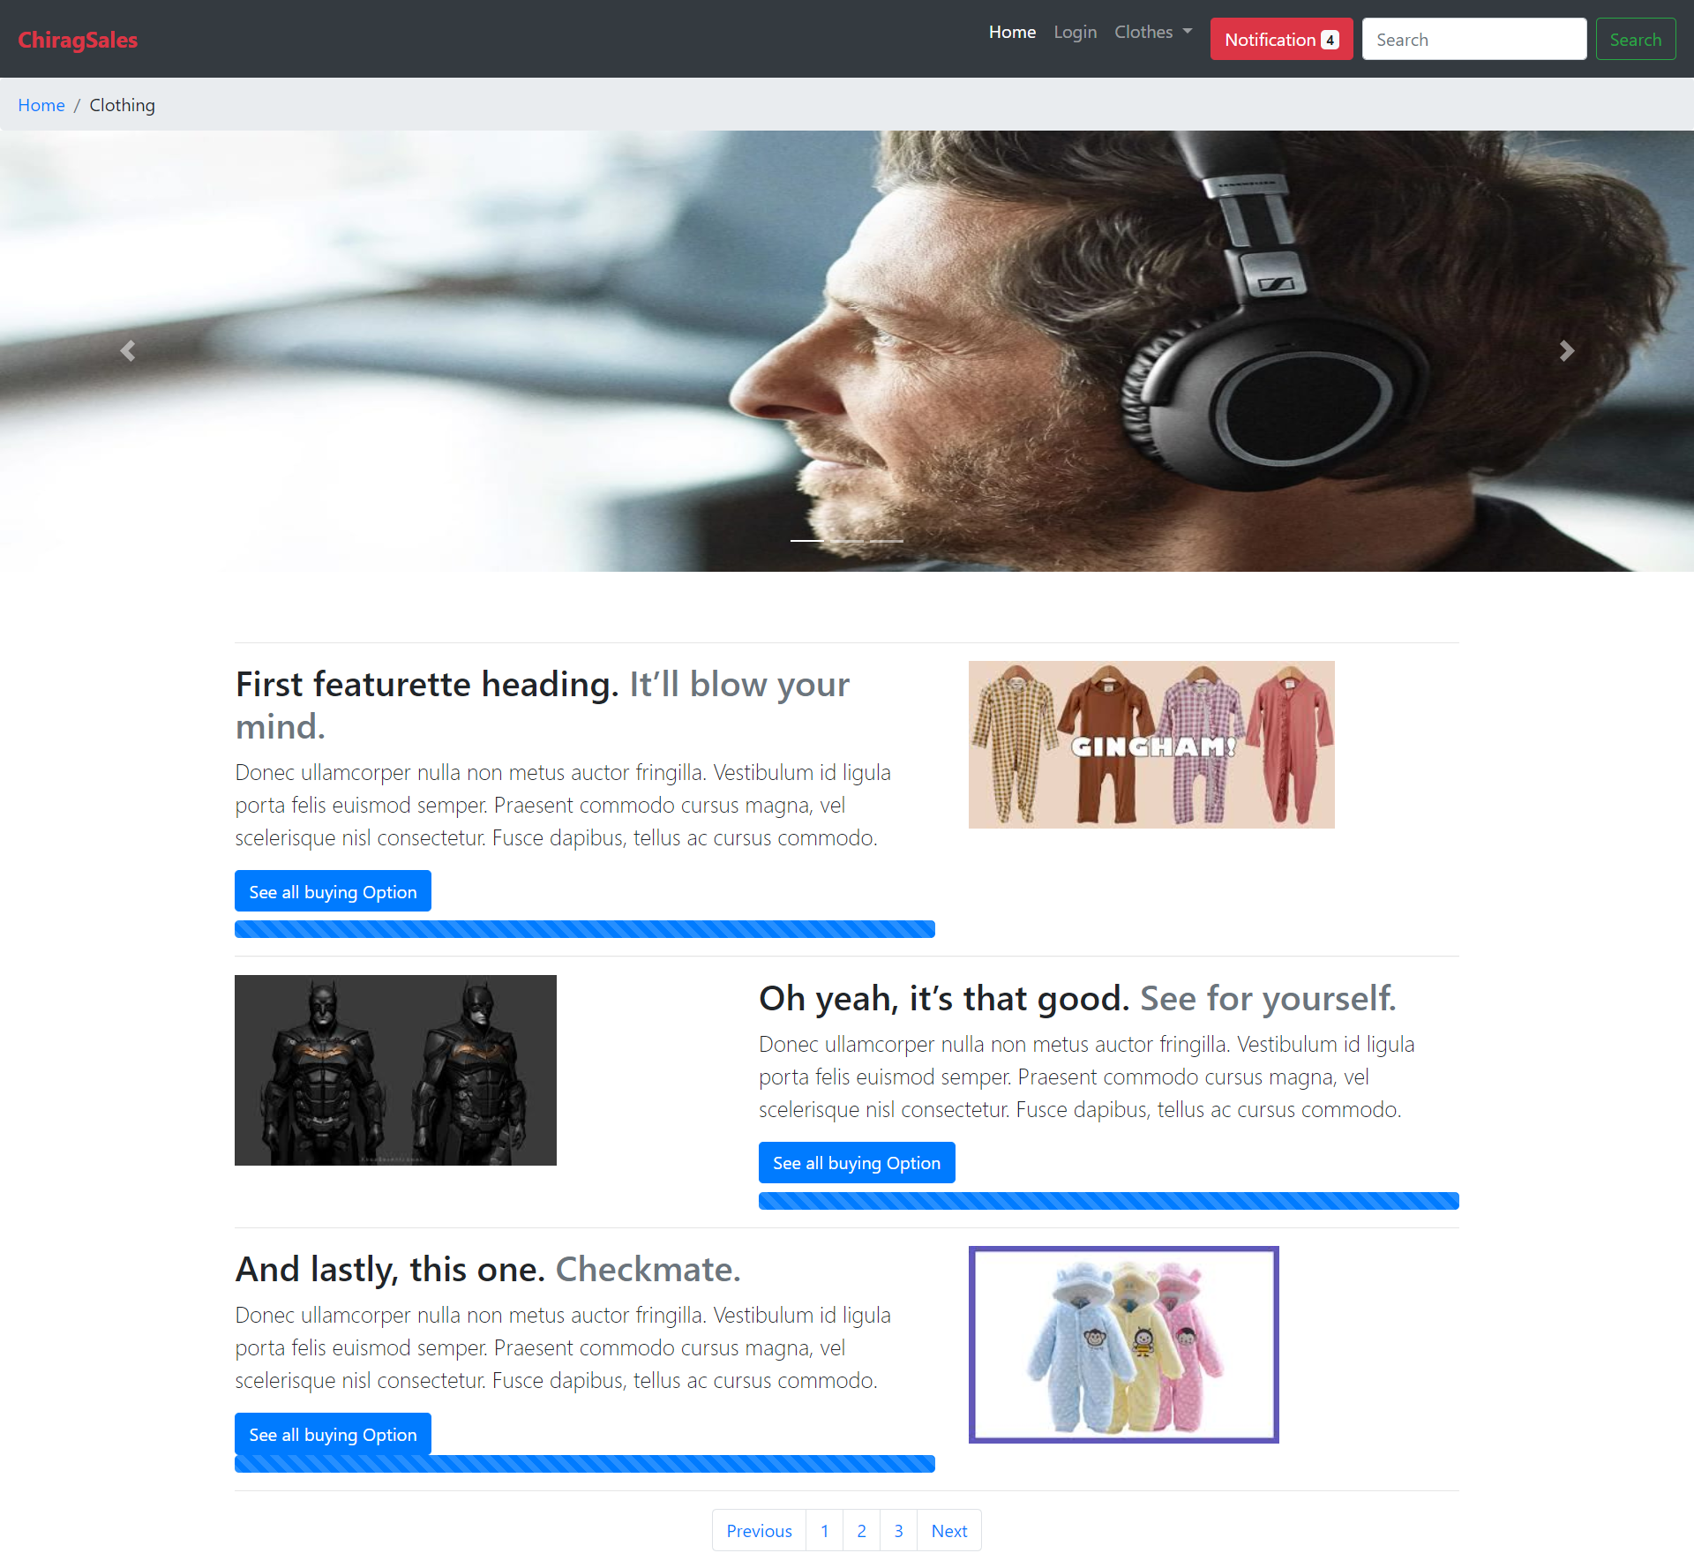:**

**HTML Code For Electronics.html**

<!doctype html>

<html lang="en">

<head>

  <!-- Required meta tags -->

  <meta charset="utf-8">

  <meta name="viewport" content="width=device-width, initial-scale=1, shrink-to-fit=no">

  <!-- Bootstrap CSS -->

  <link rel="stylesheet" href="https://stackpath.bootstrapcdn.com/bootstrap/4.4.1/css/bootstrap.min.css" integrity="sha384-Vkoo8x4CGsO3+Hhxv8T/Q5PaXtkKtu6ug5TOeNV6gBiFeWPGFN9MuhOf23Q9Ifjh" crossorigin="anonymous">

  <link rel="stylesheet" href="style.css">

  <title id="logo">ChiragSales</title>

</head>

<body>

  <!--Navigation Bar-->

  <!-- New nav -->

  <nav class="navbar navbar-expand-lg navbar-dark bg-dark sticky-top">

    <a class="navbar-brand text-danger font-weight-bold" id="logo" href="#">ChiragSales</a>

    <button class="navbar-toggler" type="button" data-toggle="collapse" data-target="#navbarSupportedContent" aria-controls="navbarSupportedContent" aria-expanded="false" aria-label="Toggle navigation">

      <span class="navbar-toggler-icon"></span>

    </button>

    <div class="collapse navbar-collapse" id="navbarSupportedContent">

      <ul class="navbar-nav ml-auto">

        <li class="nav-item active">

          <a class="nav-link" href="index.html">Home <span class="sr-only">(current)</span></a>

        </li>

        <li class="nav-item">

          <a class="nav-link" href="#">Login</a>

        </li>

        <li class="nav-item dropdown">

          <a class="nav-link dropdown-toggle" href="#" id="navbarDropdown" role="button" data-toggle="dropdown" aria-haspopup="true" aria-expanded="false">

            Electronics

          </a>

          <div class="dropdown-menu " aria-labelledby="navbarDropdown">

            <a class="dropdown-item active" href="electronics.html">Electronics</a>

            <div class="dropdown-divider"></div>

            <a class="dropdown-item" href="clothing.html">Clothes</a>

            <div class="dropdown-divider"></div>

            <a class="dropdown-item" href="furniture.html">Furniture</a>

          </div>

        </li>

        <li class="nav-item ">

          <a class="nav-link" href="#" tabindex="-1" aria-disabled="true">

            <button type="button" class="btn btn-danger">

              Notification <span class="badge badge-light">4</span>

              <span class="sr-only">unread messages</span>

            </button>

          </a>

        </li>

      </ul>

      <form class="form-inline my-2 my-lg-0">

        <input class="form-control mr-sm-2" type="search" placeholder="Search" aria-label="Search">

        <button class="btn btn-outline-success my-2 my-sm-0" type="submit">Search</button>

      </form>

    </div>

  </nav>

  <!-- BreadCrumb -->

  <nav aria-label="breadcrumb">

    <ol class="breadcrumb">

      <li class="breadcrumb-item"><a href="index.html">Home</a></li>

      <li class="breadcrumb-item" aria-current="page" >Electronics</li>

    </ol>

  </nav>

  <!-- Carouse -->

  <div id="carouselExampleIndicators" class="carousel slide" data-ride="carousel">

    <ol class="carousel-indicators">

      <li data-target="#carouselExampleIndicators" data-slide-to="0" class="active"></li>

      <li data-target="#carouselExampleIndicators" data-slide-to="1"></li>

      <li data-target="#carouselExampleIndicators" data-slide-to="2"></li>

    </ol>

    <div class="carousel-inner">

      <div class="carousel-item active">

        <img src="img/headphone.jpg" class="d-block w-100" alt="...">

      </div>

      <div class="carousel-item">

        <img src="img/clothes.jpg" class="d-block w-100" alt="...">

      </div>

      <div class="carousel-item">

        <img src="img/furniture.jpg" class="d-block w-100" alt="...">

      </div>

    </div>

    <a class="carousel-control-prev" href="#carouselExampleIndicators" role="button" data-slide="prev">

      <span class="carousel-control-prev-icon" aria-hidden="true"></span>

      <span class="sr-only">Previous</span>

    </a>

    <a class="carousel-control-next" href="#carouselExampleIndicators" role="button" data-slide="next">

      <span class="carousel-control-next-icon" aria-hidden="true"></span>

      <span class="sr-only">Next</span>

    </a>

  </div>

  <div class="container marketing">

    <!-- Three columns of text below the carousel -->

    <!-- START THE FEATURETTES -->

    <hr class="featurette-divider">

    <div class="row featurette">

      <div class="col-md-7">

        <h2 class="featurette-heading">First featurette heading. <span class="text-muted">It’ll blow your mind.</span></h2>

        <p class="lead">Donec ullamcorper nulla non metus auctor fringilla. Vestibulum id ligula porta felis euismod semper. Praesent commodo cursus magna, vel scelerisque nisl consectetur. Fusce dapibus, tellus ac cursus commodo.</p>

        <div class="progress mt-2">

          <div class="progress-bar progress-bar-striped progress-bar-animated" role="progressbar" aria-valuenow="75" aria-valuemin="0" aria-valuemax="100" style="width: 100%"></div>

        </div>

      </div>

      <div class="col-md-5">

        <img src="img/Tv.jpg" alt="">

      </div>

    </div>

    <hr class="featurette-divider">

    <div class="row featurette">

      <div class="col-md-7 order-md-2">

        <h2 class="featurette-heading">Oh yeah, it’s that good. <span class="text-muted">See for yourself.</span></h2>

        <p class="lead">Donec ullamcorper nulla non metus auctor fringilla. Vestibulum id ligula porta felis euismod semper. Praesent commodo cursus magna, vel scelerisque nisl consectetur. Fusce dapibus, tellus ac cursus commodo.</p>

        <div class="progress mt-2">

          <div class="progress-bar progress-bar-striped progress-bar-animated" role="progressbar" aria-valuenow="75" aria-valuemin="0" aria-valuemax="100" style="width: 100%"></div>

        </div>

      </div>

      <div class="col-md-5 order-md-1">

        <img class="img-fluid" src="img/6t cover.png" alt="">

      </div>

    </div>

    <hr class="featurette-divider">

    <div class="row featurette">

      <div class="col-md-7">

        <h2 class="featurette-heading">And lastly, this one. <span class="text-muted">Checkmate.</span></h2>

        <p class="lead">Donec ullamcorper nulla non metus auctor fringilla. Vestibulum id ligula porta felis euismod semper. Praesent commodo cursus magna, vel scelerisque nisl consectetur. Fusce dapibus, tellus ac cursus commodo.</p>

        <div class="progress mt-2">

          <div class="progress-bar progress-bar-striped progress-bar-animated" role="progressbar" aria-valuenow="75" aria-valuemin="0" aria-valuemax="100" style="width: 100%"></div>

        </div>

      </div>

      <div class="col-md-5 ">

        <img class="img-fluid" src="img/blutooothSpeaker.jpg" alt="">

      </div>

    </div>

    <hr class="featurette-divider">

    <!-- /END THE FEATURETTES -->

    <nav aria-label="Page navigation example">

      <ul class="pagination justify-content-center">

        <li class="page-item"><a class="page-link" href="#">Previous</a></li>

        <li class="page-item"><a class="page-link" href="#">1</a></li>

        <li class="page-item"><a class="page-link" href="#">2</a></li>

        <li class="page-item"><a class="page-link" href="#">3</a></li>

        <li class="page-item"><a class="page-link" href="#">Next</a></li>

      </ul>

    </nav>

  </div><!-- /.container -->

</div>

<!-- Optional JavaScript -->

<!-- jQuery first, then Popper.js, then Bootstrap JS -->

<script src="https://code.jquery.com/jquery-3.4.1.slim.min.js" integrity="sha384-J6qa4849blE2+poT4WnyKhv5vZF5SrPo0iEjwBvKU7imGFAV0wwj1yYfoRSJoZ+n" crossorigin="anonymous"></script>

<script src="https://cdn.jsdelivr.net/npm/popper.js@1.16.0/dist/umd/popper.min.js" integrity="sha384-Q6E9RHvbIyZFJoft+2mJbHaEWldlvI9IOYy5n3zV9zzTtmI3UksdQRVvoxMfooAo" crossorigin="anonymous"></script>

<script src="https://stackpath.bootstrapcdn.com/bootstrap/4.4.1/js/bootstrap.min.js" integrity="sha384-wfSDF2E50Y2D1uUdj0O3uMBJnjuUD4Ih7YwaYd1iqfktj0Uod8GCExl3Og8ifwB6" crossorigin="anonymous"></script>

</body>

</html>

**Output:**

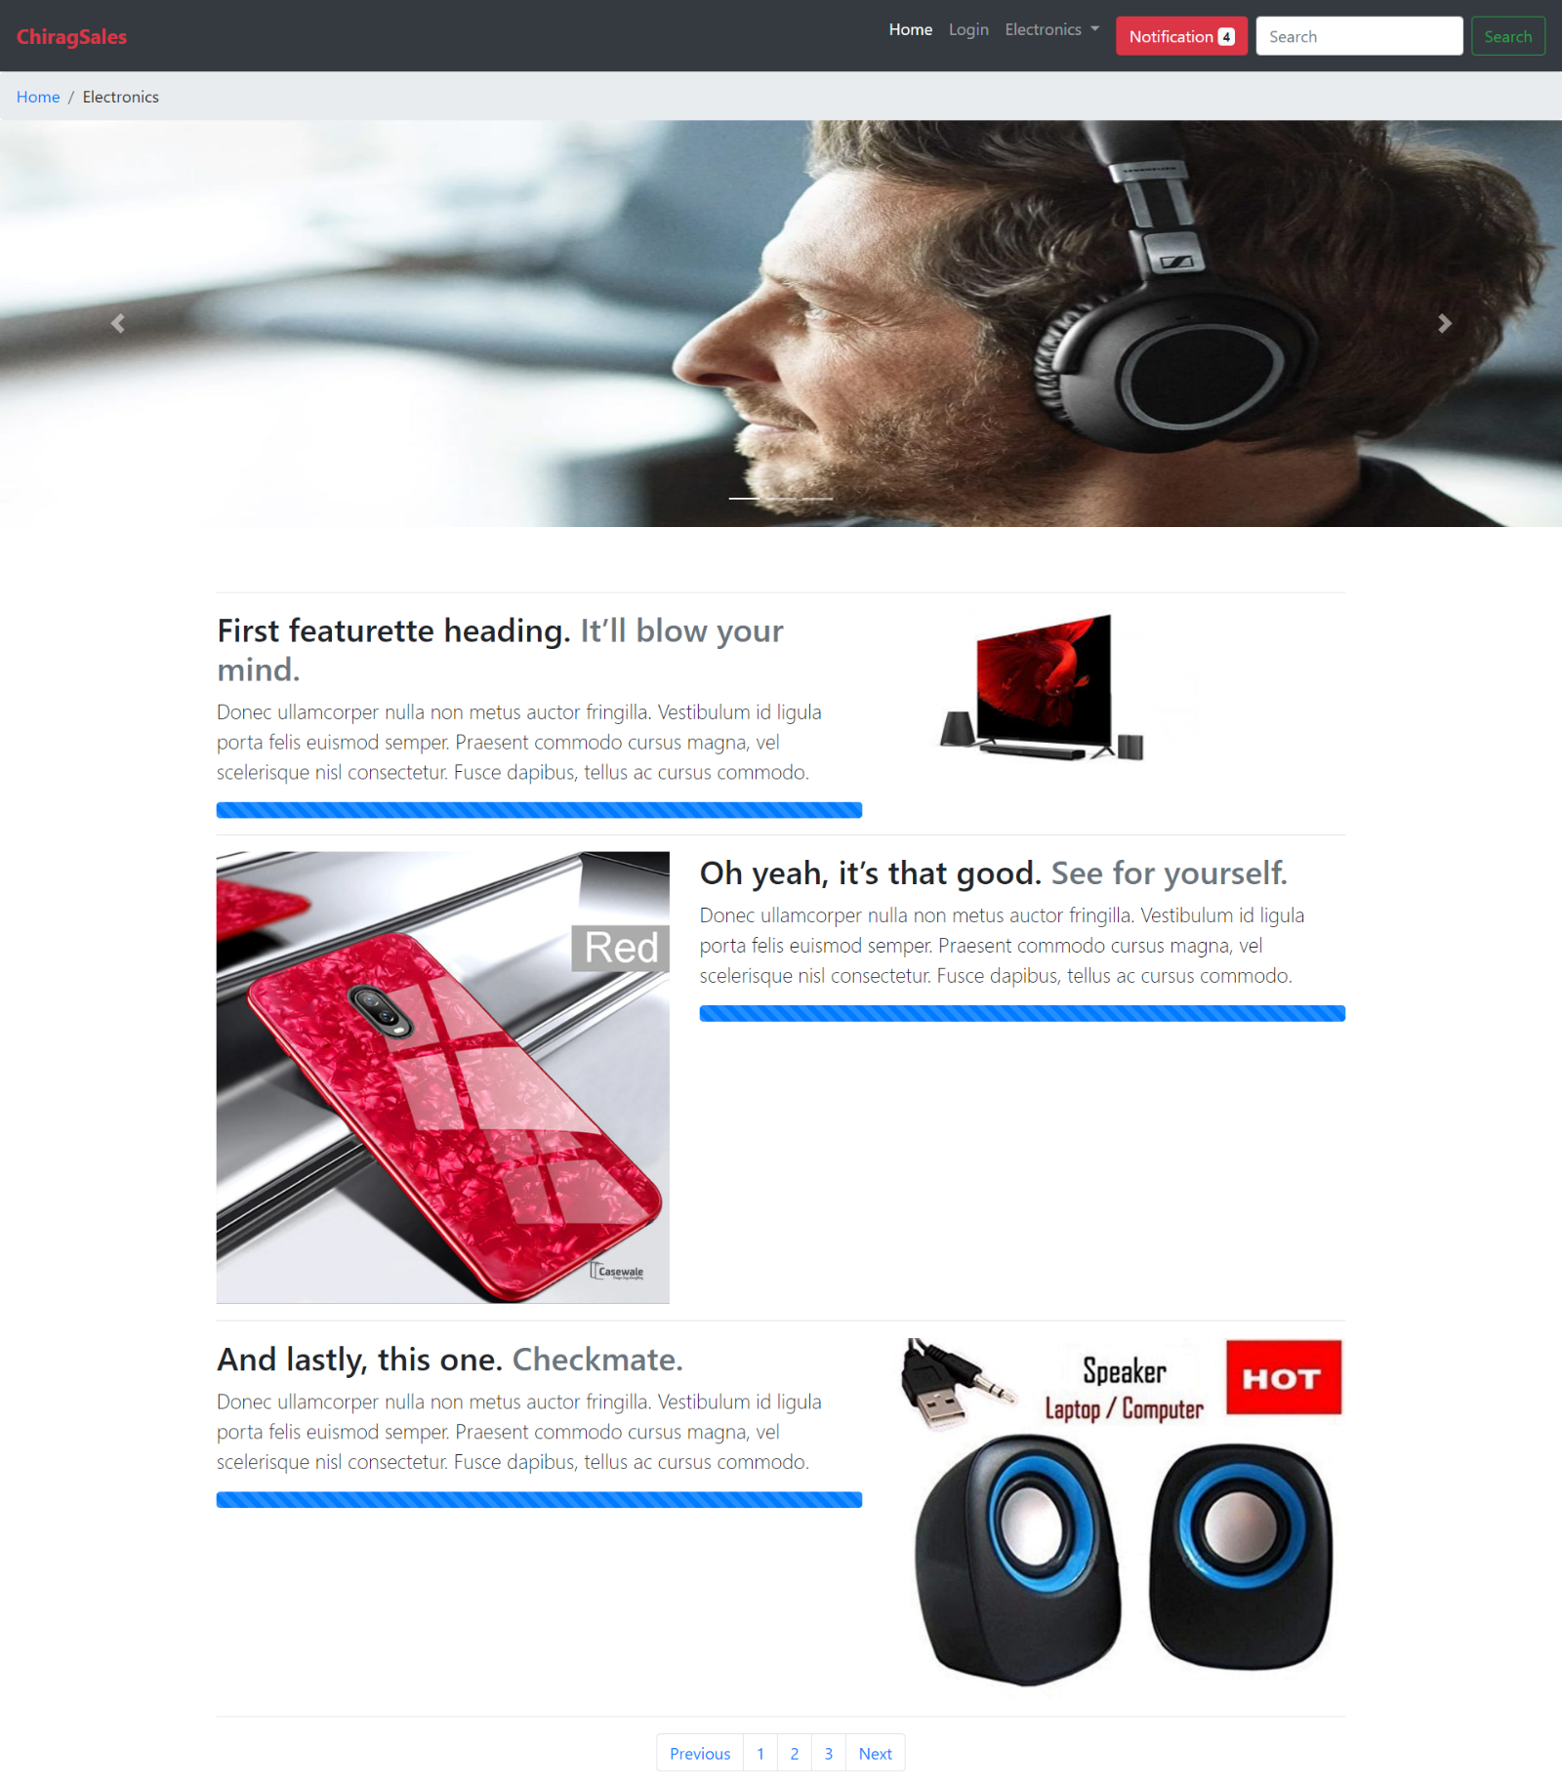

**Code For furniture.html:**

<!doctype html>

<html lang="en">

<head>

  <!-- Required meta tags -->

  <meta charset="utf-8">

  <meta name="viewport" content="width=device-width, initial-scale=1, shrink-to-fit=no">

  <!-- Bootstrap CSS -->

  <link rel="stylesheet" href="https://stackpath.bootstrapcdn.com/bootstrap/4.4.1/css/bootstrap.min.css" integrity="sha384-Vkoo8x4CGsO3+Hhxv8T/Q5PaXtkKtu6ug5TOeNV6gBiFeWPGFN9MuhOf23Q9Ifjh" crossorigin="anonymous">

  <link rel="stylesheet" href="style.css">

  <title id="logo">ChiragSales</title>

</head>

<body>

  <!-- Modal -->

  <div class="modal fade" id="exampleModal" tabindex="-1" role="dialog" aria-labelledby="exampleModalLabel" aria-hidden="true">

    <div class="modal-dialog" role="document">

      <div class="modal-content">

        <div class="modal-header">

          <h5 class="modal-title" id="exampleModalLabel">Notifications</h5>

          <button type="button" class="close" data-dismiss="modal" aria-label="Close">

            <span aria-hidden="true">&times;</span>

          </button>

        </div>

        <div class="modal-body">

          <ul class="m-2">

            <li class="my-1">

              <button class="btn btn-primary">1</button>

              Would you like the offer

            </li>

            <li class="my-1">

              <button class="btn btn-primary">2</button>

              Would you like the offer

            </li>

            <li class="my-1">

              <button class="btn btn-primary">3</button>

              Would you like the offer

            </li>

            <li class="my-1">

              <button class="btn btn-primary">4</button>

              Would you like the offer

            </li>

            <li class="my-1">

              <button class="btn btn-primary">5</button>

              Would you like the offer

            </li>

          </ul>

        </div>

        <div class="modal-footer">

          <button type="button" class="btn btn-secondary" data-dismiss="modal">Close</button>

          <button type="button" class="btn btn-primary">Clear All</button>

        </div>

      </div>

    </div>

  </div>

  <!--Navigation Bar-->

  <nav class="navbar navbar-expand-lg navbar-dark bg-dark sticky-top">

    <a class="navbar-brand text-danger font-weight-bold" id="logo" href="#">ChiragSales</a>

    <button class="navbar-toggler" type="button" data-toggle="collapse" data-target="#navbarSupportedContent" aria-controls="navbarSupportedContent" aria-expanded="false" aria-label="Toggle navigation">

      <span class="navbar-toggler-icon"></span>

    </button>

    <div class="collapse navbar-collapse" id="navbarSupportedContent">

      <ul class="navbar-nav ml-auto">

        <li class="nav-item active">

          <a class="nav-link" href="index.html">Home <span class="sr-only">(current)</span></a>

        </li>

        <li class="nav-item">

          <a class="nav-link" href="#">Login</a>

        </li>

        <li class="nav-item dropdown">

          <a class="nav-link dropdown-toggle" href="#" id="navbarDropdown" role="button" data-toggle="dropdown" aria-haspopup="true" aria-expanded="false">

            Furniture

          </a>

          <div class="dropdown-menu " aria-labelledby="navbarDropdown">

            <a class="dropdown-item " href="electronics.html">Electronics</a>

            <div class="dropdown-divider"></div>

            <a class="dropdown-item" href="clothing.html">Clothes</a>

            <div class="dropdown-divider"></div>

            <a class="dropdown-item active" href="furniture.html">Furniture</a>

          </div>

        </li>

        <li class="nav-item ">

          <a class="nav-link" href="#" tabindex="-1" aria-disabled="true">

            <button type="button" class="btn btn-danger" data-toggle="modal" data-target="#exampleModal">

              Notification <span class="badge badge-light">4</span>

              <span class="sr-only">unread messages</span>

            </button>

          </a>

        </li>

      </ul>

      <form class="form-inline my-2 my-lg-0">

        <input class="form-control mr-sm-2" type="search" placeholder="Search" aria-label="Search">

        <button class="btn btn-outline-success my-2 my-sm-0" type="submit">Search</button>

      </form>

    </div>

  </nav>

  <!-- BreadCrumb -->

  <nav aria-label="breadcrumb">

    <ol class="breadcrumb">

      <li class="breadcrumb-item"><a href="index.html">Home</a></li>

      <li class="breadcrumb-item" aria-current="page" >Furniture</li>

    </ol>

  </nav>

  <!-- Carouse -->

  <div id="carouselExampleIndicators" height="" class="carousel slide" data-ride="carousel">

    <ol class="carousel-indicators">

      <li data-target="#carouselExampleIndicators" data-slide-to="0" class="active"></li>

      <li data-target="#carouselExampleIndicators" data-slide-to="1"></li>

      <li data-target="#carouselExampleIndicators" data-slide-to="2"></li>

    </ol>

    <div class="carousel-inner">

      <div class="carousel-item active">

        <img src="img/headphone.jpg" class="d-block w-100" alt="...">

      </div>

      <div class="carousel-item">

        <img src="img/clothes.jpg" class="d-block w-100" alt="...">

      </div>

      <div class="carousel-item">

        <img src="img/furniture.jpg" class="d-block w-100" alt="...">

      </div>

    </div>

    <a class="carousel-control-prev" href="#carouselExampleIndicators" role="button" data-slide="prev">

      <span class="carousel-control-prev-icon" aria-hidden="true"></span>

      <span class="sr-only">Previous</span>

    </a>

    <a class="carousel-control-next" href="#carouselExampleIndicators" role="button" data-slide="next">

      <span class="carousel-control-next-icon" aria-hidden="true"></span>

      <span class="sr-only">Next</span>

    </a>

  </div>

  <div>

    <div class="container marketing">

      <!-- Three columns of text below the carousel -->

      <!-- START THE FEATURETTES -->

      <hr class="featurette-divider">

      <div class="row featurette">

        <div class="col-md-7">

          <h2 class="featurette-heading">First featurette heading. <span class="text-muted">It’ll blow your mind.</span></h2>

          <p class="lead">Donec ullamcorper nulla non metus auctor fringilla. Vestibulum id ligula porta felis euismod semper. Praesent commodo cursus magna, vel scelerisque nisl consectetur. Fusce dapibus, tellus ac cursus commodo.</p>

          <div class="progress mt-2">

            <div class="progress-bar progress-bar-striped progress-bar-animated" role="progressbar" aria-valuenow="75" aria-valuemin="0" aria-valuemax="100" style="width: 100%"></div>

          </div>

        </div>

        <div class="col-md-5">

          <img src="https://ii1.pepperfry.com/media/catalog/product/b/e/494x544/beautiful-swing-with-white-canopy-in-brown-finish-by-aura-beautiful-swing-with-white-canopy-in-brown-yfddut.jpg" alt="">

        </div>

      </div>

      <hr class="featurette-divider">

      <div class="row featurette">

        <div class="col-md-7 order-md-2">

          <h2 class="featurette-heading">Oh yeah, it’s that good. <span class="text-muted">See for yourself.</span></h2>

          <p class="lead">Donec ullamcorper nulla non metus auctor fringilla. Vestibulum id ligula porta felis euismod semper. Praesent commodo cursus magna, vel scelerisque nisl consectetur. Fusce dapibus, tellus ac cursus commodo.</p>

          <div class="progress mt-2">

            <div class="progress-bar progress-bar-striped progress-bar-animated" role="progressbar" aria-valuenow="75" aria-valuemin="0" aria-valuemax="100" style="width: 100%"></div>

          </div>

        </div>

        <div class="col-md-5 order-md-1">

          <img src="img/bed.jpg" alt="">

        </div>

      </div>

      <hr class="featurette-divider">

      <div class="row featurette">

        <div class="col-md-7">

          <h2 class="featurette-heading">And lastly, this one. <span class="text-muted">Checkmate.</span></h2>

          <p class="lead">Donec ullamcorper nulla non metus auctor fringilla. Vestibulum id ligula porta felis euismod semper. Praesent commodo cursus magna, vel scelerisque nisl consectetur. Fusce dapibus, tellus ac cursus commodo.</p>

          <div class="progress mt-2">

            <div class="progress-bar progress-bar-striped progress-bar-animated" role="progressbar" aria-valuenow="75" aria-valuemin="0" aria-valuemax="100" style="width: 100%"></div>

          </div>

        </div>

        <div class="col-md-5">

          <img src="https://mlyhqh0d5fss.i.optimole.com/-8KDBg-p_eoCY52/w:auto/h:auto/q:auto/https://palletfurniture.in/wp-content/uploads/2020/01/CTPT005-1-e1578376725563.png" alt="">

        </div>

      </div>

      <hr class="featurette-divider">

      <!-- /END THE FEATURETTES -->

      <nav aria-label="Page navigation example">

        <ul class="pagination justify-content-center">

          <li class="page-item"><a class="page-link" href="#">Previous</a></li>

          <li class="page-item"><a class="page-link" href="#">1</a></li>

          <li class="page-item"><a class="page-link" href="#">2</a></li>

          <li class="page-item"><a class="page-link" href="#">3</a></li>

          <li class="page-item"><a class="page-link" href="#">Next</a></li>

        </ul>

      </nav>

    </div><!-- /.container -->

  </div>

  <!-- Optional JavaScript -->

  <!-- jQuery first, then Popper.js, then Bootstrap JS -->

  <script src="https://code.jquery.com/jquery-3.4.1.slim.min.js" integrity="sha384-J6qa4849blE2+poT4WnyKhv5vZF5SrPo0iEjwBvKU7imGFAV0wwj1yYfoRSJoZ+n" crossorigin="anonymous"></script>

  <script src="https://cdn.jsdelivr.net/npm/popper.js@1.16.0/dist/umd/popper.min.js" integrity="sha384-Q6E9RHvbIyZFJoft+2mJbHaEWldlvI9IOYy5n3zV9zzTtmI3UksdQRVvoxMfooAo" crossorigin="anonymous"></script>

  <script src="https://stackpath.bootstrapcdn.com/bootstrap/4.4.1/js/bootstrap.min.js" integrity="sha384-wfSDF2E50Y2D1uUdj0O3uMBJnjuUD4Ih7YwaYd1iqfktj0Uod8GCExl3Og8ifwB6" crossorigin="anonymous"></script>

</body>

</html>

**Output:**

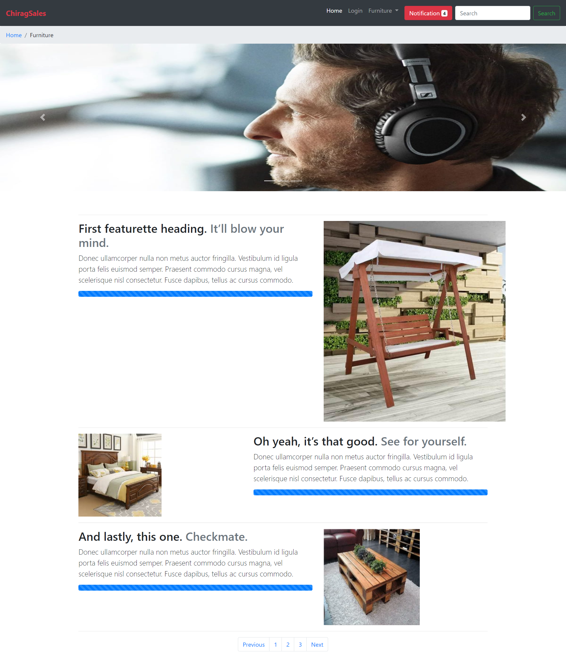

**Output of the Modal:**

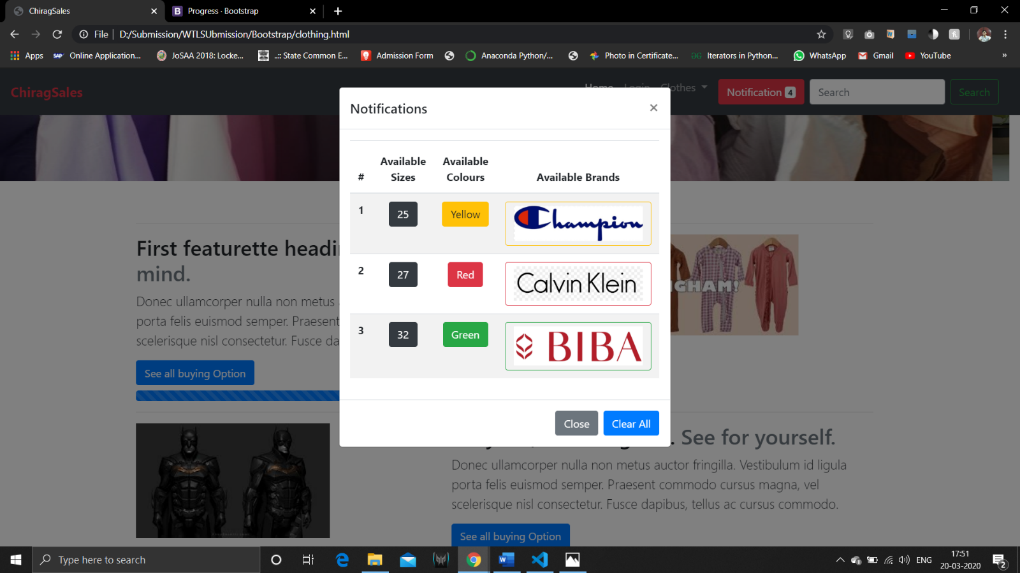

**Conclusion:**

* 1. **I implemented Bootstrap and understood how easy can it be to design a website using it.**
  2. **I also successfully implemented giithub repository for the first time.**
  3. **I understood about the classes and different components made by Bootstrap.**